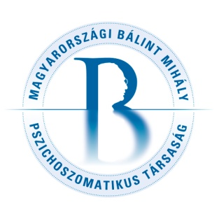Registration
for the 6th Balint Group Weekend of the Hungarian Michael Balint Society for Psychosomatics
3-5 June 2016

Name:

Profession, speciality:

Address:

Phone and mail:

Registration for two-days-program (one night, 3 meals, groups on Friday and Saturday) 130 Euros: yes or no

Registration for three-days-program (two nights, 6 meals, all programs) 180 Euros: yes or no

We provide 50% reduced price for all colleagues from former socialist countries.

Accommodation in one-bed room (extra 15 Euros/night): yes or no

If accommodated in two-bed-room, I share my room with:

Extra lunch on Friday (10 Euros): yes or no

Extra dinner on Saturday for two-days-program participants: 10 Euros (for three-days-program participants it is included in the registration fee): yes or no

Special requests (vegetarian, lactose-free etc):

Registration fee should be transferred to Magyarországi Bálint Mihály Pszichoszomatikus Társaság IBAN HU57117860012006073800000000 until 31 May
or paid by cash on the congress’ site.
Thank you for your data. Please send this application form to balinttarsasag@gmail.com.

